CAS PY 106

Prelecture Note 25

1. Reflections (fixed end)
2. How waves reflect at the ends of a medium, or at the interface between two media, is critical to understanding things like musical instruments
3. When a wave encounters a fixed end, for instance, it comes back upside down
4. Reflections (free end)
5. When a wave encounters a free end, it comes back upright
6. Standing Waves
7. When identical waves travel in opposite directions in a medium, the result is a standing wave – a wave that does not travel one way or the other
8. 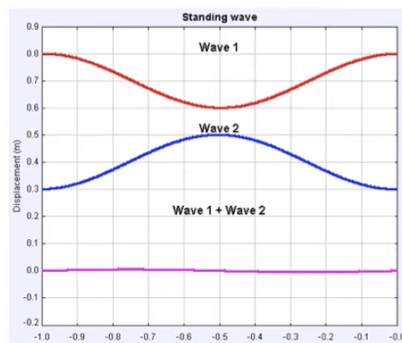
9. The euqations for the waves are:

y1 = A\*sin(kx-wt)

y2 = A\*sin(kx+wt)

The sum can be written as: y = 2\*a\*sin(kx)\*cos(wt)

1. This is not a traveling wave, because the spatial part is separated from the time part. The string is totally flat at certain instants in time, and there are certain positions where the amplitude is always zero – called nodes
2. There are other points halfway between the nodes where the amplitude is maximum- called anti-nodes
3. Standing waves: a string fixed at both ends
4. A wave traveling in one direction on the string reflects off the end, and returns inverted because the end is fixed
5. Completely constructive interference between these waves takes place only when the wavelength is related to the length L of the string by:

n \* lambda / 2 = L

where n = 1, 2, 3,…

1. Using f = v / lambda, the corresponding frequencies are:

f = n\*v / 2L

1. The lowest resonance frequency (n=1) is known as the fundamental frequency for the string.
2. All the higher frequencies are known as harmonics – these are integer multiples of the fundamental frequency
3. 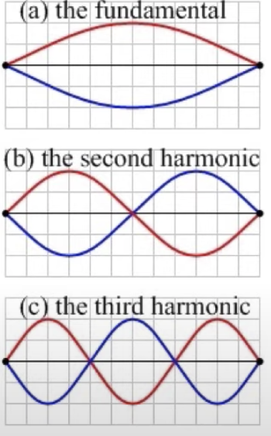
4. 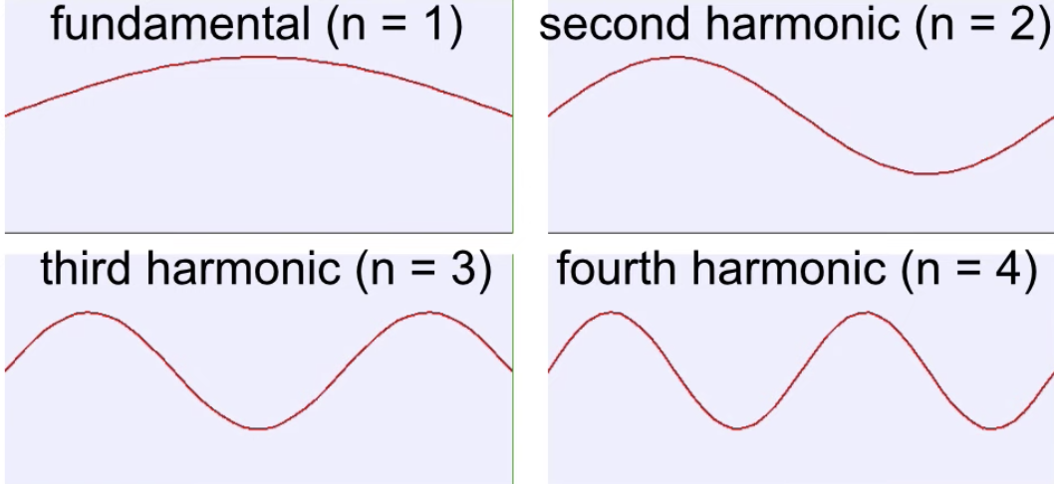
5. A pipe closed at one end
6. For a pipe with only one end open, we get a different result than we get with both ends open
7. The condition for resonance, in that case, is that the standing wave has an anti-node at the open end, but it has a node at the closed end
8. The resonance condition is satisfied only when an odd integer number of quarter wavelengths fit into the length of the pipe
9. There are no even harmonics (even multiples of the fundamental), and the third harmonic is three times the frequency of the fundamental, the fifth harmonic is five times the frequency
10. N’th harmonic is n times the fundamental:

n \* lambda / 4 = L

OR

Lambda = 4L/n

1. Using the equation v = f \* lambda,

f = v / lambda = nv/4L